Huge economic benefits from a new runway ???

In its publicity the Airports Commission claimed there would be “up to £147 billion benefit” from a third runway at Heathrow.
This was eagerly seized on by Heathrow, Back Heathrow and some politicians.
Spot the flaw ?
“Up to £147 billion” could mean anything – even zero or negative !
***************************************************************
The reason for this vagueness becomes clear if one reads the damning comments the Commission’s own “Expert Advisors” made about the “novel” studies used to produce this figure:
“While the content of the model itself has been well tested, the same cannot be said of the front end, where an increase in capacity is converted into an increase in trip-making, trade, tourism and finally productivity. Furthermore the interpretation of the result – what exactly do they mean and is their basis transparent – is an issue. Overall, therefore, we counsel caution in attaching significant weight either to the absolute or relative results of the GDP/GVA SCGE approach (PwC report) within the Economic Case”.
A more conventional economic analysis - WebTag - produced ‘wider economic impacts’ of just £11.5bn or £7.7bn, according to the Airports Commission.
Less than 1/10th !
****************************************************************
But the claims are even more misleading than that. The lobbyists for expansion have picked on an economic benefit without taking into account costs. In order to justify a project, it is essential to look at the NET benefit - that is benefits less costs. If one picked a benefit and ignored costs, one could conclude bank robberies are beneficial to the UK economy because there is a benefit to the bank robber!
The Airports Commission actually looked at the whole picture using the government’s established methodology called ‘Webtag’ for evaluating infrastructure projects. This gave a value of £1.4 billion. See table in the appendix, copied directly from the Airport’s Commission final report.
This may seem like at large sum, but it is spread over a period of 60 years and over the whole UK with over 60 million people. Placed in context, the net benefit is miniscule. The net economic benefit is equal to the dregs of a cup of coffee for each airport passenger !
The figure of £1.4 billion was derived on that basis that a limit should be placed on carbon emissions from aviation in order to meet the UK’s climate commitments. If no constraint was placed on aviation’s carbon emissions, the net benefit was estimated at £11.8 billion. But in context this is still miniscule. The net economic benefit is still less than a third of the cost of a cup of coffee for each airport passenger !
It can be seen from the table that even these values required the addition of a sum for ‘wider economic impacts’ which is not even part of the official Webtag methodology. Without these, the net benefits are close to zero or negative.
*********************************************************
Appendix - Evidence From The Airports Commission
The following table is from the Airports Commission’s final report (p147). It uses the official ‘Webtag’ methodology for evaluating infrastructure projects.
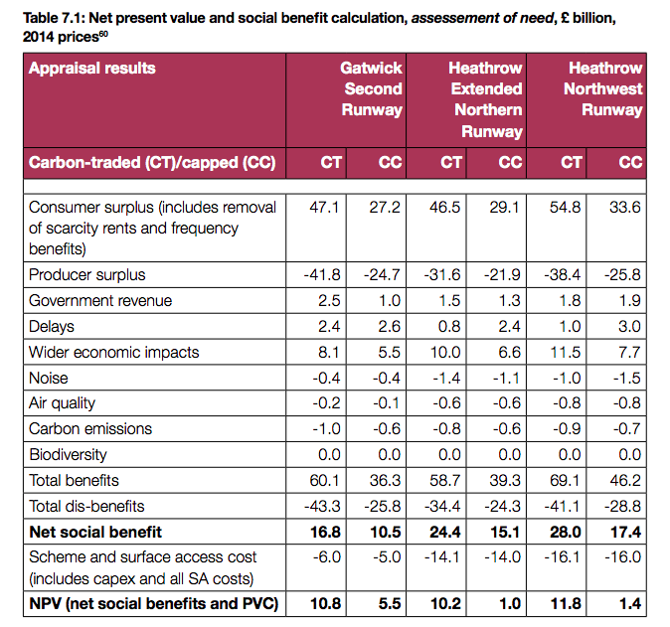

Notes on the table
1. The last two columns show the various costs and benefits of Heathrow expansion with a north-west runway as compared with no new runway. The figures are all ‘Net Present Values’. They are produced by summing all costs and benefits over a 60 year period after applying a ‘discount factor’ for each year.
2. There are two separate estimates – carbon traded (CT) and carbon capped (CC). Carbon capped is where aviation’s carbon emissions are constrained in order to meet the UK’s climate commitments. Carbon traded is where there is no constraint on carbon emissions.
3. ‘Wider economic impacts’ of £11.5 bn and £7.7 bn are shown, which contrast hugely with figures such as £147 bn claimed by supporters of expansion.
4. Summing the various costs and benefits, the Airport Commission produced final overall Net Present Values for third runway of £11.8 bn (carbon traded) and £1.4 bn (carbon capped.)
5. These NPV values of £11.8bn and £1.4bn include ‘wider economic impacts’. Those impacts are not even part of the official Webtag methodology. If they had not been tacked on, the net economic benefits would have been +£0.3bn or -£6.3bn.
6. A notable feature of the Airports Commission’s results is the large uncertainties (doubts) about many of the costs. For example, Transport for London estimated the surface access costs to be £12bn higher. Transport for London also highlighted the fact that the Commission optimised flight paths with 3 runways but not with 2 runways, making the noise costs about £3bn too low. Such uncertainties are so large compared with the overall NPV that there can be no assurance whatever that the overall NPV would be positive.

Contact details
Nic Ferriday, West London Friends of the Earth
0208 357 8426 ; 07873 388453 ; wlfoe@btinternet.com

From ‘A Note from Expert Advisors, Prof. Peter Mackie and Mr Brian Pearce, on key issues considering the Airports Commission’, May 2015. This was published at the same time as the final report. It is telling that the final report itself did not reveal this damning criticism.
At 2050 there are forecast to be about 400 million trips pa. The economic benefit of £1.4 billion is a ‘present value’ over 60 years. We make a simple assumption that there are no benefits for 20 of these years because a new runway would not be operational until about 2026 and because present valuing means the Net Present Value is somewhat less than the sum of the present value for each year. The number of passengers over 40 years is 40 x 400m = £16 billion. Economic benefit per passenger is then 1.4 bn/16bn = 9 pence. This is equivalent to the dregs of a cup of airport coffee.
Using a similar calculation, the economic benefit per passenger is 73 pence, less than a third of the cost of a cup of airport coffee.
The discount factor takes account of the fact that costs and benefits further into the future are deemed to be less important than ones sooner. Discount factors are in effect an inverse of interest rates.

