
Exchange

Newsletter for Aviation Campaigners across Europe

No 8 October 2012
------------------------------------------------------------------

24th November
European Day of Action against Night Flights

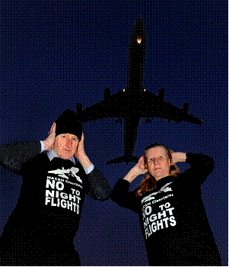
If you would like to organize an event, email johnstewart2@btconnect.com

On 24th November there will be a Europe-wide Day of Action against Night Flights. The theme will be ‘Ban Night Flights’. The purpose of the day is to show to politicians and the media the huge opposition there is to night flights amongst the citizens across Europe. Already we know that campaigners in Germany, Britain and Belgium are organizing activities. If you would like to organize a protest in your country or at your airport can you email me at johnstewart2@btconnect.com. The protest can take any form you want. It does not need to involve a lot of people. The aim of the day is to get pictures of protests across Europe.

Night flights can make you ill
HYENA, an international study carried out by Imperial College in London, published in 2008, found that noise from night flights causes immediate increases in blood pressure in sleeping people, even if they are not woken up by the noise. There is a 14% increase in the risk of high blood pressure (hypertension) for each 10 decibel increase in night-time aircraft noise. Hypertension can lead to heart problems and even early death. The study looked at 4,861 people aged between 45 and 70 who had lived near Heathrow, Schiphol, Berlin Tegel, Stockholm Arlanda, Milan Malpensa and Athens Elephterios Venizelos airports for at least 5 years: http://www.ncbi.nlm.nih.gov/pmc/articles/PMC1310905/
Frankfurt: A Year of Protests

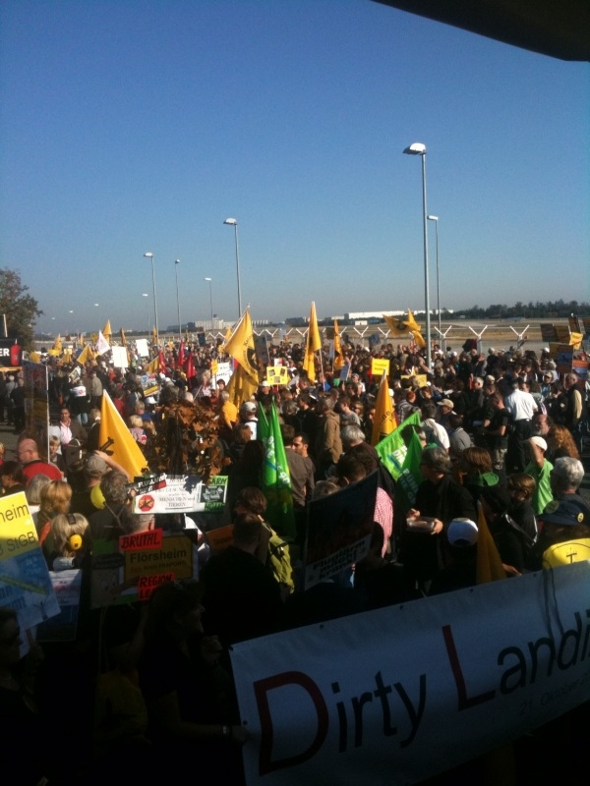
Thousands of campaigners came to a major protest to mark the first anniversary of the opening of the 4th runway at Frankfurt Airport on Sunday 21st October. The protest rally was held just beside the runway. Speakers included UECNA President John Stewart.
“It is an historic achievement. Never before have protests continued for so long after a runway has been opened”. John Stewart

Every Monday evening since the runway opened the campaigners have occupied the airport terminal in protest against the impact of the new runway. Tens of thousands of people who are now overflown argue that they were misled by the authorities about where the new flight paths would be.

The protests have caused the politicians big problems. At the recent elections for Mayor of Frankfurt, the candidate of the ruling Christian Democratic Union (CDU) party was defeated by the Socialist candidate who supported the campaigners. The campaigners have also won a ban on night flights from 23.00 hours to 05.00 hours. The campaigners intend to continue their weekly protests in order to influence the national and regional elections which will be held in Germany in 2013.

Ciampino campaigners expose Ryanair’s false claims

The budget airline, Ryanair, claims that it has created 4,000 jobs in Rome since it started using Ciampino Airport a few years ago. These claims have been ridiculed by the local campaigners. In a press release they said: "If tomorrow Ryanair claims the Colosseum in Rome exists only because of them, calm them down! We can prove with absolute certainty that it already existed". The campaigners show that Ryanair takes money out of the Italian economy. They quote the Corriere della Sera newspaper which found that Italy has lost at least 500 million euros in taxes in recent years because Ryainair has been allowed to pay its taxes in countries with a lower rate of tax. They also show that some Italian airports have paid Ryanair to use the airport or charged them very low landing fees.
Aircraft noise has become a major problem for residents at Ciampino Airport since Ryanair started using the airport a few years ago. Many communities live very close to the airport.

Nantes: The Police Move In
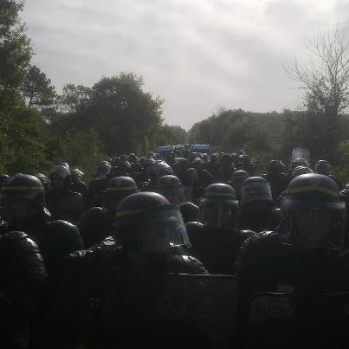
There were dramatic scenes this month outside Nantes as thousands of police moved into the area to evict people who were living in houses that are on the route of the proposed new airport.

The airport has not yet got permission to be built as the campaigners are still fighting the plans in the courts. However, the police moved in to evict some of the people who had occupied houses in the area to support the local campaigners.

You can view the scenes by clicking on to these links. The first is a short news

report. The second is a long, but dramatic, film by the campaigners of protests facing armed police as they try to stop houses being knocked down to make way for the proposed new airport. The third is a short you tube video of campaigners urging drivers to drive slowly on a nearby highway in support of the protest: http://youtu.be/CJAWSQd5z4M;http://vimeo.com/52063732;http://youtu.be/pCxWEq2QxYQ.

There have been rallies in support of the Nantes campaigners in other cities in France. And national organizations have written to the French Prime Minister calling on the airport to be stopped. These organizations include Greenpeace France, Attac France, Acting for the Environment, Climate Action Network France, Friends of the Earth, Confédération Paysanne, Future Generations, United, Landscapes of France, Right to Housing and the National Federation of Transport Users Associations.
The Nantes campaigners write:
Located 18 km from the centre of Nantes, the new airport would not solve the problems of the current city airport. It would only move the noise to a new area. It would affect more than 80,000 residents in the northern suburbs of Nantes. It would mean the construction of many new roads, railways and bridges. The cost of these would lead to budget cuts in other areas such as education and health. The new airport would significantly increase greenhouse gas emissions, (despite the Government’s declared intention to reduce them). Unlike the claims of its supporters, the airport would not be "good for jobs." Many of the “new” jobs would be as a result of companies relocating. It would destroy many existing jobs. We commissioned a report from the independent economic consultants CE Delft which showed that the economic costs of the new airport would outweigh its benefits.

Important Legal Challenge by Vienna Campaigners

A decision due to be made on 8th November by the European Court of Justice could have major implications for campaigners across Europe. The court will decide whether compensation should be paid to residents who experience noise as a result of new flight paths being introduced. The compensation would be paid for loss of value of their property. The case has been brought by AFLG (Antifluglärmgemeinschaft) which consists of the 38 citizens' initiatives who are opposed to the proposed 3rd runway at Vienna Airport. More details about the challenge in this newspaper article:
http://diepresse.com/home/panorama/wien/1302939/Schwechat_Todesstoss-fuer-3-Flughafenpiste?parentid=2981514&showMask=1

Tell us your news!

Each newsletter will have a section about what is happening in the different campaigns in the different countries around Europe.
Campaigning and Information Sheets
UECNA has published short campaigning and briefing sheets to assist organizations with their campaigning: http://www.uecna.eu/spip.php?article161
- Let us know what is happening at your airports

- Send us information about events you are holding or campaigns your are doing

- Tell us about your successes……and failures!

- Make this newsletter a real exchange of information

Also send your material to the UECNA website: www.uecna.eu email JP Pago on jp.pago@free.fr

If you want to be able to track the flight paths in your area, UECNA can help. Look at www.dfld.de or email Horst Weise on mail@DFLD.de

Two very useful websites:

- Transport and Environment (T & E): http://www.transportenvironment.org/

- European Environmental Bureau (EEB): http://www.eeb.org/

Two sites which show you whether your airport and the airlines using it is losing or gaining passengers:

http://www.anna.aero/european-airline-traffic-trends/

http://www.anna.aero/european-airport-traffic-trends/

If you have videos you want to share, email them to johnstewart2@btconnect.com

This newsletter has been published by UECNA.
We are a network of airport community campaign groups across Europe. Our main concern is the noise for residents living around the airports and under the flight paths. We have regular meetings, organize conferences and take part in marches, demonstrations and other visible activities. We also lobby the European Parliament and the European Commission. To find out more visit our website: www.uecna.eu
If your group is interested in joining UECNA, email johnstewart2@btconnect.com

