Nightmare of Night Flights

Impact on Health

All the new evidence points in the same direction: night flights can damage people’s health.

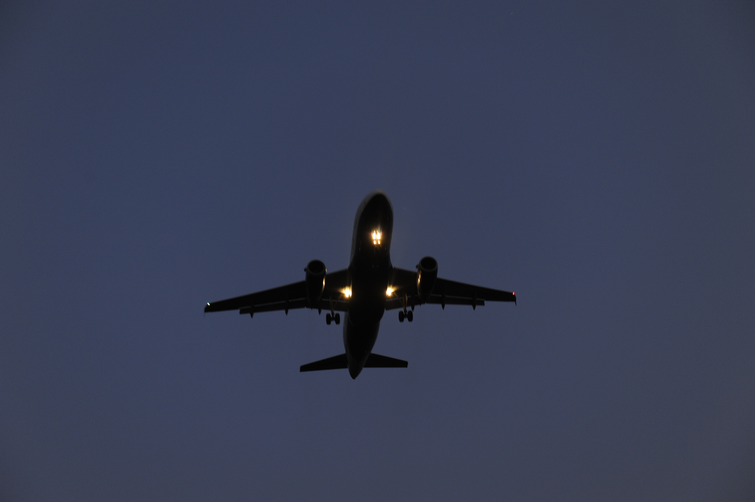

The last Labour Government continued to maintain night flights had little impact on health.

It was relying on outdated evidence.

The new evidence shows a clear link between night flight noise and health.

The new Government needs to base its policy on the most up-to-date research available.

Night Flights Harm Our Health

The evidence is compelling. There are a number of reports.

The HYENA Study

HYENA (1), published in 2008, is an international study carried out by Dr Lars Jarup and his team at Imperial College in London. It looked at 4,861 people aged between 45 and 70 who had lived near Heathrow, Berlin Tegel, Amsterdam Schiphol, Stockholm Arlanda, Milan Malpensa and Athens Elephterios Venizelos airports for at least five years. It found that noise from night flights causes immediate increases in blood pressure in sleeping people, even if they are not woken up by the noise. It discovered a 14% increase in the risk of high blood pressure (hypertension) for each 10 decibel increase in night-time aircraft noise. Hypertension can lead to heart problems and even early death.
A 10 decibel increase in night-time aircraft noise increases the risk of high blood pressure by 14%

Two other pieces of research, the Erikson Study (2) and the Cologne Medication Study (3) yielded similar results.

Swiss National Cohort Study

The Swiss Cohort Study (4), carried out by Dr Matthias Egger and his colleagues at the University of Berne, found that living under a flight path increases the risk of a getting heart attack. It discovered that people exposed to a daily average noise levels of at least 60 decibels are 30% more at risk of dying of a heart attack than those exposed to less that 45 decibels. Among those exposed to the higher decibel levels for 15 or more years, the risk was 50 per cent higher. Up to 200,000 people under the Heathrow flight paths experience noise averaging out at over 60 decibels.

The World Health Organisation Study

The World Health Organisation (WHO) Study, Night Noise Guidelines for Europe (5) published in 2009, found:

- If sleep is regularly disturbed for any reason, it has an effect on people’s health.

- Even if people don’t wake up, there is “sufficient evidence” to show that noise increases people’s heart-rate, exactly the same finding as the HYENA Report.

- People whose sleep is regularly disturbed take more medicines.

- There is some, but “limited”, evidence that noise at night can cause heart problems, depression and other mental illness.

- Children, including babies, because they spend longer in bed, are “considered a risk group” even though they usually sleep through noise better than adults.

- Since older people, pregnant woman and ill people find sleeping more difficult, they are particularly vulnerable to being disturbed by night noise.

Why Eight Hours is Important

An eight hour night protects at least 50% of people

The Centre for Time Use Research, published in 2006 (6), showed that adults spend around 7.5 hours in bed. The amount of time they are actually asleep is somewhat shorter. But, due to personal factors like age, there is considerable variation in the amount of sleep people need. To allow for this, the World Health Organisation recommends an 8 hour night which would protect around 50% of the population - it would take a period of 10 hours to protect 80%. On Sundays, sleeping time is consistently 1 hour longer. Young children also have longer sleeping times.

Current Policy is based on Outdated Research

The research, by Dr John Ollerhead (7), on which government policy has been based, is now regarded as outdated. Its key assumption – that people’s health might only be affected if they were woken up by night flights – is challenged by the new studies. Bluhm and Nordling in their review of Swedish studies (8) concluded: “Sleep disorders in the form of waking up are little suited for evaluation purposes.”
The key assumption behind government policy – that people’s health might only be affected if they are woken up by night flights – is challenged by the new studies

Ollerhead’s study focused on whether or not people were woken up. He accepted that people could be stressed if woken up by aircraft noise but his definition of “being woken up” was strange. He claimed that only if the person goes back to sleep after being woken does it count as sleep disturbance. If a person stayed awake after being woken up that does not count - even if the reason s/he cannot get back to sleep again is noise from more aircraft! On that basis he argued that few people’s health was disturbed.

Despite the huge number of complaints from people under the flight paths which seemed to contradict Ollerhead’s findings, they were accepted by the last Government. Tony Blair’s first aviation minister, the actress turned politician, Glenda Jackson, went as far as to “reiterate that the Department has no reason to doubt the validity and reliability of the methodology employed in the 1992 sleep research, or its findings.”
More up-to-date research shows that people’s health can still be affected by night flights even if they remain asleep

But doubts began to emerge. Ollerhead himself admitted his study was not comprehensive. Under cross-examination at the Terminal 5 Inquiry, he acknowledged it only covered sleep deprivation; it did not include annoyance from night flights which he admitted could cause stress. The Government commissioned two further studies. The Adverse effects of night-time aircraft noise (9) continued to argue that “there appears to be no hard scientific evidence of significant health impairment”. But Aircraft noise and sleep disturbance (10), which concentrated on the periods just after people go to sleep and before they wake up, edged towards the fact the night noise might be damaging to health by recommending further research into “the hypothetical relationship between sleep disturbance and long-term health effects.” But Research has moved on. The new Government would do well to adopt a new policy based on the more up-to-date research.
The Government would do well to abandon its out-of-date studies and just rely on recent research

The World Health Organisation Recommendations

The new WHO Guidelines for night noise suggest two-stage approach:

- an interim target where outdoor noise averaged out over an eight hour night should be no higher than 55 decibels (what is called 55 Lnight).

- leading to a final target where the average outdoor noise should be no higher than 40 decibels (40 Lnight).

At Heathrow 55 Lnight is exceeded over a wide area – from Barnes in the east to Windsor in the west. But people further afield are also affected by night flights. Remember Lnight simply denotes the area where noise averages out at 55 decibels or more. But, it is the actual noise which people can find most disturbing - particularly at night when the background noise levels are low. More than 20 miles from Heathrow the actual noise of night flights can exceed 70 decibels.

References and Key Reports
(1). Hypertension and exposure to noise near airports, Jarup et al, 2008
(2). Aircraft noise and incidence of hypertension, Eriksson et al, 2007
(3). Cologne Medication Study
(4). Aircraft Noise, Air Pollution, and Mortality, Egger et al, published in Epidemiology, November 2010, Volume 21, Issue 6, pp 829-836
(5). Night Noise Guidelines for Europe, World Health Organisation, 2009
(6). Centre for Time Use Research: www.timeuse.org/access/
(7). Community Noise and blood pressure, Bluhm and Nording, Internoise Review 2006
(8). Report of a Field Study of Aircraft Noise and Sleep Disturbance, Ollerhead et al, DoT, 1992
(9). Adverse effects of night-time aircraft noise, Porter et al, DORA for DETR, 2000
(10). Aircraft noise and sleep disturbance, Flindell et al, CAA, 2000

-----------------------------------------------------------------------------------------

Be Part of our Campaign
The current agreement on night flights runs until October 2014. The Government is expected to start consulting on a new agreement later this year.

What we are calling for:

- A ban on flights between 11pm and 6am.

- A phased reduction in flights between 6am and 7am.

- Alternation of flight paths at night so everybody gets some nights without flights.

What we can all do:

- Write to/email our MPs – see our website for details: www.hacan.org.uk

- Watch out for events and petitions throughout the year – check www.hacan.org.uk

- Join HACAN - £13 is a small price to pay for a good night’s sleep! Contact us or go to our website.

Published by HACAN, representing people under the Heathrow flight paths, PO Box 339, Twickenham,TW1 2XF; 020 8876 0455; info@hacan.org.uk; www.hacan.org.uk Photos by Phil Weedon.
Printed by RAP Spiderweb; Jan/Feb 2013

