Official Complaint to GAL/CAA/DfT – Flight RAM672S 31st December 2014

Before Hartfield RAM672 is already below 4,000 ft. It is flying NE, away from the airport.
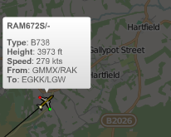
It dips below 3,000 at Ashurst turning to the N
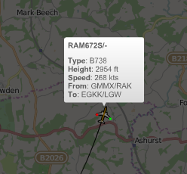
Just before Penshurst someone making ‘vectoring choices’ clearly felt that it was not far enough E and it corrected at 2,700 ft above Fordcombe.
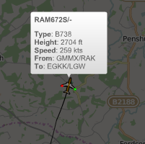

Overhead Penshurst RAM672 had dipped below 2,500 ft and was heading due N.
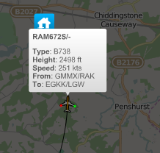
Overhead TN8 7AA it executed a ludicrously tight and totally unnecessary turn with all of the attendant noise that you would expect at below 2,000 ft – more than 14 miles from the tarmac.
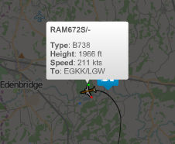
It struggled over Hever Castle at 1700 ft.
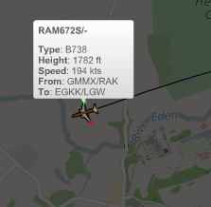

The bigger picture shows the ludicrously exaggerated loop planes are being sent down and the following plane at below 3,000 ft above Penshurst shows that this is now a regular occurence.

